Yifu He 190003956

Homework 7

Problem 1

Q1. Mean and covariance



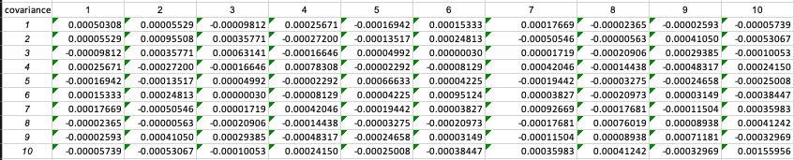

Q2. Describe the efficient frontier in one-fund theorem

The total excel is here

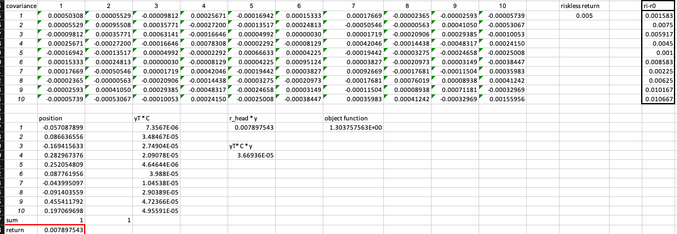

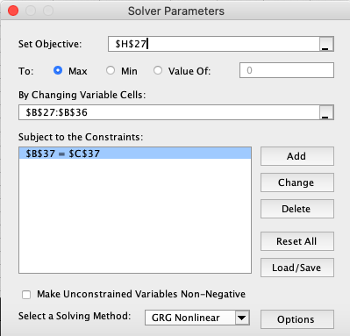

rj -r0:



Final portfolio:

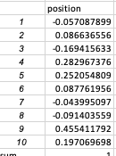

Maximum sharpe ratio:



Return:



Q3:

When short is now allowed: we add one more constrain that yi >= 0.

The whole excel:

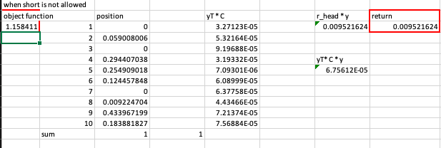

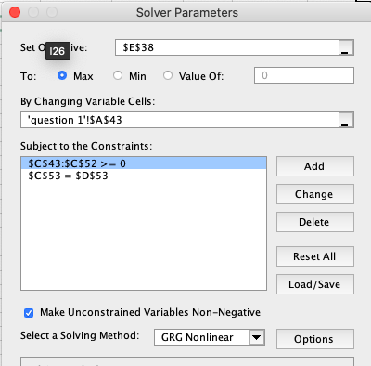

Position:

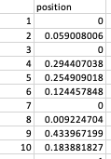

Return:



Construct frontier using different portion of riskless assets.

Problem 2

When the distribution of different scenario are equal to 1/12.

The whole excel is here:

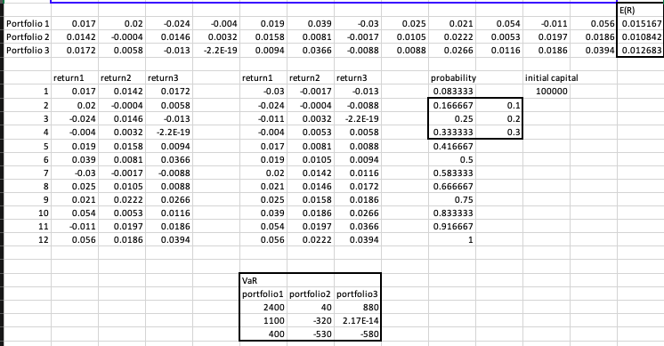

The Expected return are:



The situation of alpha = 0.1, 0.2, 0.3 lies in

Calculate the VaR = return\*initial asset

Problem3

When the distribution of different assets are joint normal distribution,

The whole excel is here:

We got the standardized score:

We got the expected return and standard variation for different portfolio:

Then we calculate the VaR = Mean – std\*standard score

